## PROGRAM DEFINITION

|  |
| --- |
|  |
| * Program untuk cetak laporan deposit |

## RELATED TABLES

|  |  |
| --- | --- |
|  | **Access** |
| * PMT_AGREEMENT_DEPOSIT | * RW |

## ROLES

|  |  |
| --- | --- |
|  | **Test** |
| * User yg mempunyai akses ke program |  |

## INITIAL PROCESS

|  |  |
| --- | --- |
|  | **Test** |
| * Set VAR_COMPANY_ID = Login User’s Company ID * Set VAR_USER_ID = Login User ID * Set VAR_LANGUAGE_ID = Login User’s Language ID * Get Property List to Combobox Property [PROPERTY_LIST]:   EXEC RSP_GS_GET_PROPERTY_LIST ‘VAR_CCOMPANY_ID’, ‘VAR_LANGUAGE_ID’  Set Value : CPROPERTY_ID Set Display : CPROPERTY_NAME  As Parameter: CPROPERTY_ID   * Jalankan RSP_GS_GET_PERIOD_YEAR_RANGE dengan parameter, simpan hasil ke VAR_GSM_PERIOD   + VAR_COMPANY_ID   + ‘’ (Empty String)   + ‘’ (Empty String) * Jalankan RSP_CB_GET_SYSTEM_PARAM dengan parameter, simpan hasil ke VAR_CB_SYSTEM_PARAM   + VAR_COMPANY_ID   + VAR_LANGUAGE_ID |  |

## MAIN FORM

### USER INTERFACE

#### INITIAL VERSION

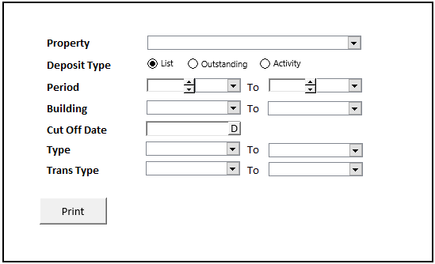

### BUTTON DEFINITION

|  |  |
| --- | --- |
| **Button Name** | **Action** |
| Print | Jalankan PRINT REPORT PROCESS |
|  |  |

### DISPLAY PROCESS

#### FIELD DEFINITION

|  |  |  |  |
| --- | --- | --- | --- |
| **Name** | **Field** | **Type** | **Validation** |
| Property | Set Value : CPROPERTY_ID  Set Display : CPROPERTY_NAME  As Parameter: CPROPERTY_ID | Combobox | * Mandatory * Get DataSource from [PROPERTY_LIST] * IF Combobox Empty   + Display message “Please select property !” |
| Deposit | Set Value if List = True  CDEPOSIT_TYPE = “1” if Outsanding = True  CDEPOSIT_TYPE = “2” else  CDEPOSIT_TYPE = “3” | Radio Button | * Default Value = List * IF Radio Checked = List   Enable: Period, Building.  Set empty on: Cutt off date, type, trans type.   * IF Radio Checked = Outstanding Enable: Cut Off Date.   Set empty on: Period, building, type, trans type   * IF Radio Checked = Activity Enable: Period, Building, Type, Trans Type.   Set empty on: Cutt off date |
| Period From Year | As Parameter: CFROM_YEAR | Spinner   * Minimum Value = VAR_GSM_PERIOD.IMIN_YEAR * Minimum Value = VAR_GSM_PERIOD.IMAX_YEAR * Stepping value = 1   Set Default selected value = VAR_CB_SYSTEM_PARAM.CSOFT_PERIOD_YY | * Default Value = Year.Today * Enable on = Radio Checked : List, Activity |
| Period Month From | As Parameter: CFROM_MONTH | Combobox  Isi combobox dengan RSP_GS_GET_PERIOD_DT_LIST dengan parameter:   * VAR_COMPANY_ID * Year.Today   Set Item Code=CPERIOD_NO  Set Item Name=CPERIOD_NO | * Default Value = Month.Today * Enable on = Radio Checked : List, Activity |
| Period Year To | As Parameter: CTO_YEAR | Spinner   * Minimum Value = VAR_GSM_PERIOD.IMIN_YEAR * Minimum Value = VAR_GSM_PERIOD.IMAX_YEAR * Stepping value = 1   Set Default selected value = VAR_CB_SYSTEM_PARAM.CSOFT_PERIOD_YY | * Default Value = Year.Today * Enable on = Radio Checked : List, Activity |
| Period Month To | As Parameter: CTO_MONTH | Combobox  Isi combobox dengan RSP_GS_GET_PERIOD_DT_LIST dengan parameter:   * VAR_COMPANY_ID * Year.Today   Set Item Code=CPERIOD_NO  Set Item Name=CPERIOD_NO | * Default Value = Month.Today * Enable on = Radio Checked : List, Activity |
| Building From | As Parameter: CFROM_BUILDING | Combobox  Isi combobox dengan RSP_GS_GET_BUILDING_LIST dengan parameter:   * VAR_COMPANY_ID * Selected Property Id * 1 * VAR_USER_ID   Set Item Code=CBUILDING_ID  Set Item Name=CBUILDING_NAME | * Enable on = Radio Checked : List, Activity |
| Building To | As Parameter: CTO_BUILDING | Combobox  Isi combobox dengan RSP_GS_GET_BUILDING_LIST dengan parameter:   * VAR_COMPANY_ID * Selected Property Id * 1 * VAR_USER_ID   Set Item Code=CBUILDING_ID  Set Item Name=CBUILDING_NAME | * Enable on = Radio Checked : List, Activity |
| Cut Off Date | As Parameter: CCUT_OFF_DATE | Datetime Picker | * Default Value = Date.Today * Enable on = Radio Checked : Outstanding |
| Type From | As Parameter: CFROM_TYPE | Combobox for now hardcode binding source (Contractor, Customer) | * Enable on = Radio Checked : Activity |
| Type To | As Parameter: CTO_TYPE | Combobox for now hardcode binding source (Contractor, Customer) | * Enable on = Radio Checked : Activity |
| Trans Type From | As Parameter: CFROM_TRANS_TYPE | Combobox for now hardcode binding source (LOI, Agreement) | * Enable on = Radio Checked : Activity |
| Trans Type To | As Parameter: CTO_TRANS_TYPE | Combobox for now hardcode binding source (LOI, Agreement) | * Enable on = Radio Checked : Activity |

### PRINT REPORT PROCESS

#### REPORT LAYOUT

PAPER SIZE: A4 LANDSCAPE

##### DEPOSIT TYPE : LIST (CDEPOSIT_TYPE = “1”)

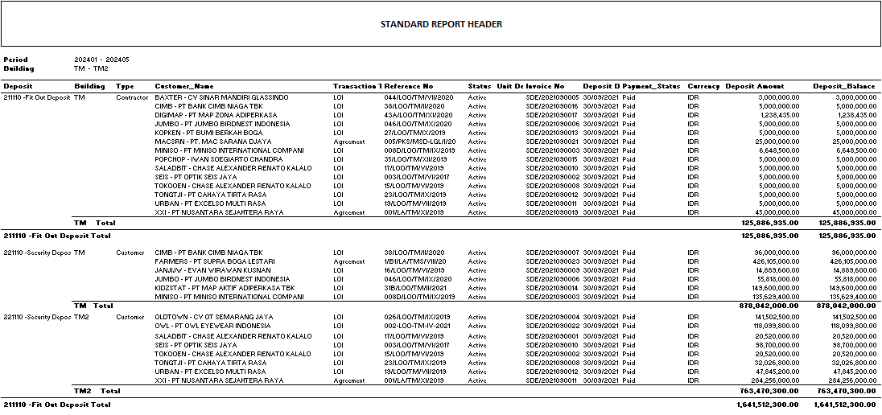

###### REPORT DEFINITION

|  |  |  |  |
| --- | --- | --- | --- |
| **Report** | **Name** | **Field** | **Validation** |
| **HEADER** | Period | Selected From Period – Selected To Period |  |
| Building | Selected From Building – Selected To Building |  |
|  |  |  |
|  |  |  |
|  |  |  |
|  |  |  |
|  |  |  |
|  |  |  |
| **REPORT GROUP** | Deposit | CDEPOSIT |  |
| Building | CBUILDING_ID |  |
|  |  |  |
|  |  |  |
|  |  |  |  |
|  |  |  |
|  |  |  |
|  |  |  |
| Detail | Deposit | CDEPOSIT_ID – CDEPOSIT_NAME |  |
| Building | CBUILDING_ID |  |
| Deposit Type | CDEPOSIT_TYPE |  |
| Customer Name | CCUSTOMER_NAME |  |
| Transaction Type | CTRANSACTION_TYPE |  |
| Reference No | CREFERENCE_NO |  |
| Status | CSTATUS |  |
| Unit Description | CUNIT_DESC |  |
| Invoice No | CINVOICE_NO |  |
| Deposit Date | CDEPOSIT_DATE |  |
| Payment status | CPAYMENT_STATUS |  |
| Currency | CCURRENCY_CODE |  |
| Deposit Amount | NDEPOSIT_AMOUNT |  |
| Deposit Balance | NDEPOSIT_BALANCE |  |
|  |  |  |
| GROUP FOOTER | Building Total | SUM NDEPOSIT_AMOUNT, SUM NDEPOSIT_BALANCE BY GROUP BUILDING |  |
| Deposit Total | SUM NDEPOSIT_AMOUNT, SUM NDEPOSIT_BALANCE BY GROUP DEPOSIT |  |
|  |  |  |
|  |  |  |
|  |  |  |

###### VALIDATION

|  |  |  |
| --- | --- | --- |
| **Field** | **Condition** | **Validation Message** |
| Department | Empty | Please select Department ! |
| Period Year | Period Year=Empty | Please select Period Year ! |
| Period Month | Period Month=Empty | Please select Period Month! |
|  |  |  |
|  |  |  |
|  |  |  |
|  |  |  |
|  |  |  |

##### DEPOSIT TYPE : OUTATANDING (CDEPOSIT_TYPE = “2”)

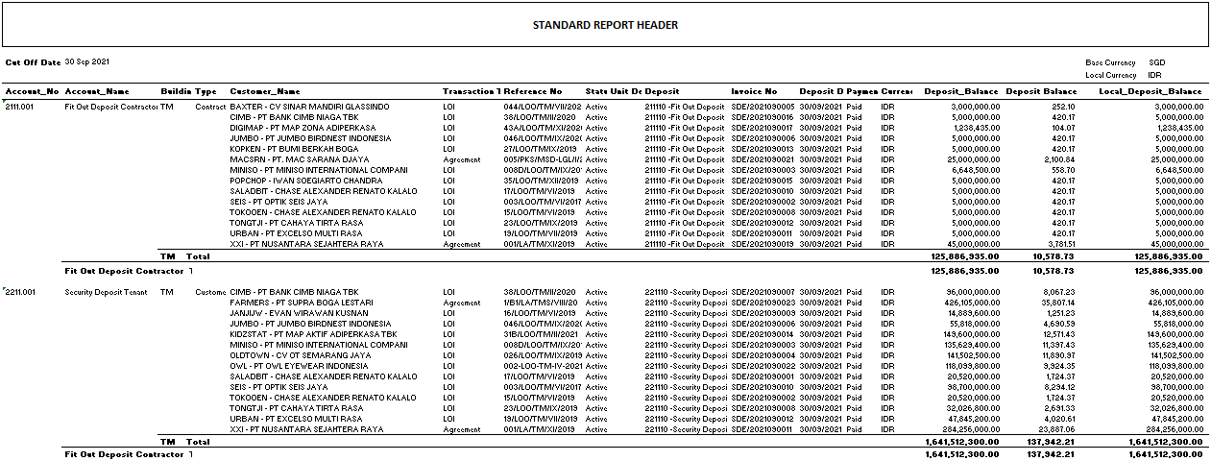

###### REPORT DEFINITION CR1

|  |  |  |  |
| --- | --- | --- | --- |
| **Report** | **Name** | **Field** | **Validation** |
| **HEADER** | Cutt Off Date | Selected Cutt Off Date |  |
|  |  |  |
|  |  |  |
|  |  |  |
|  |  |  |
|  |  |  |
|  |  |  |
|  |  |  |
| **REPORT GROUP** | Account No | CACCOUNT_NO |  |
| Building | CBUILDING_ID |  |
|  |  |  |
|  |  |  |
|  |  |  |  |
|  |  |  |
|  |  |  |
|  |  |  |
| Detail | Account No | CACCOUNT_NO |  |
| Account Name | CACCOUNT_NAME |  |
| Building | CBUILDING_ID |  |
| Deposit Type | CDEPOSIT_TYPE |  |
| Customer Name | CCUSTOMER_NAME |  |
| Transaction Type | CTRANSACTION_TYPE |  |
| Reference No | CREFERENCE_NO |  |
| Status | CSTATUS |  |
| Unit Description | CUNIT_DESC |  |
| Invoice No | CINVOICE_NO |  |
| Deposit Date | CDEPOSIT_DATE |  |
| Payment status | CPAYMENT_STATUS |  |
| Currency | CCURRENCY_CODE |  |
| ~~Deposit Balance~~  Deposit Balance | ~~NDEPOSIT_AMOUNT CR1~~  NDEPOSIT_BALANCE |  |
| ~~Deposit Balance~~  Base Deposit Balance | ~~NDEPOSIT_BALANCE CR1~~  NBASE_DEPOSIT_BALANCE |  |
| Local Deposit Balance | NLOCAL_DEPOSIT_BALANCE |  |
|  |  |  |
| GROUP FOOTER | Building Total | SUM NDEPOSIT_AMOUNT, SUM NDEPOAIT_BALANCE, NLOCAL_DEPOSIT_BALANCE BY GROUP BUILDING |  |
| Account Total | SUM NDEPOSIT_AMOUNT, SUM NDEPOAIT_BALANCE, NLOCAL_DEPOSIT_BALANCE BY GROUP DEPOSIT |  |
|  |  |  |
|  |  |  |
|  |  |  |

###### VALIDATION

|  |  |  |
| --- | --- | --- |
| **Field** | **Condition** | **Validation Message** |
| Cutt Off Date | Empty | Please select Cutt Off Date ! |
|  |  |  |
|  |  |  |
|  |  |  |
|  |  |  |
|  |  |  |
|  |  |  |
|  |  |  |

##### DEPOSIT TYPE : ACTIVITY (CDEPOSIT_TYPE = “3”)

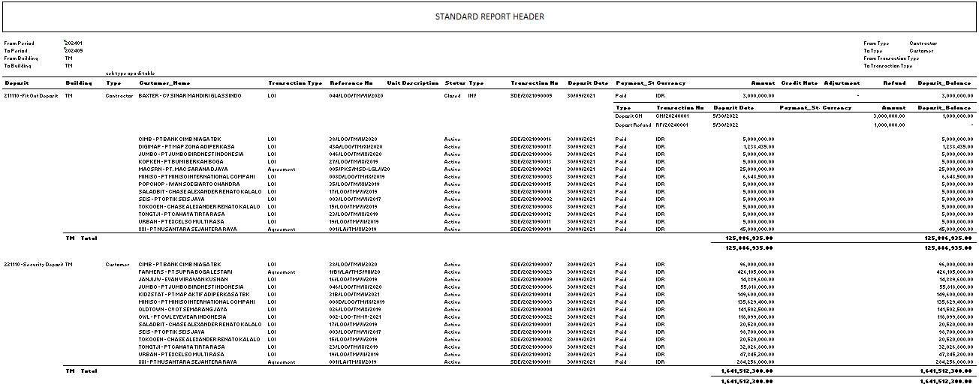

CR1 (excel sheet “Deposit Activity”)

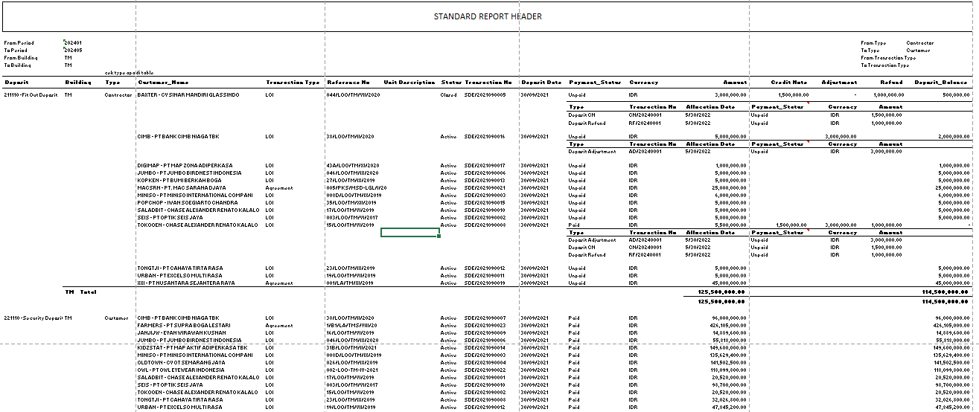

###### REPORT DEFINITION CR1

|  |  |  |  |
| --- | --- | --- | --- |
| **Report** | **Name** | **Field** | **Validation** |
| **HEADER** | From Period | Selected From Period |  |
| To Period | Selected To Period |  |
| From Building | Selected From Building |  |
| To Building | Selected To Building |  |
| From Type | Selected From Type |  |
| To Type | Selected To Type |  |
| From Transaction Type | Selected From Transaction Type |  |
| From Transaction Type | Selected To Transaction Type |  |
|  |  |  |
| **REPORT GROUP** | Deposit | CDEPOSIT_ID – CDEPOSIT_NAME |  |
| Building | CBUILDING_ID |  |
| Reference No | CREFERENCE_NO |  |
|  |  |  |
| Group Reference No | Deposit | CDEPOSIT_ID – CDEPOSIT_NAME | Supress if duplicated |
| Building | CBUILDING_ID | Supress if duplicated |
| Deposit Type | CDEPOSIT_TYPE | Supress if duplicated |
| Customer Name | CCUSTOMER_NAME |  |
| Transaction Type | CTRANSACTION_TYPE |  |
| Reference No | CREFERENCE_NO |  |
| Unit Description | ~~CUNIT_DESCRIPTION CR1~~  CUNIT_DESC |  |
| Status | CSTATUS |  |
| Invoice No | CINVOICE_NO |  |
| Deposit Date | CDEPOSIT_DATE |  |
| Payment status | CPAYMENT_STATUS |  |
| Currency | CCURRENCY_CODE |  |
| Amount | ~~NAMOUNT CR1~~  NDEPOSIT_AMOUNT |  |
| Credit Note | NCREDIT_NOTE |  |
| Adjustment | NADJUSTMENT |  |
| Refund | NREFUND |  |
| Deposit Balance | NDEPOSIT_BALANCE | Put the last value on each group on group header |
|  |  |  |
|  |  |  |
|  |  |  |
| Detail | Deposit Type | CDETAIL_DEPOSIT_TYPE |  |
| Transaction No | CDETAIL_TRANSACTION_NO |  |
| Deposit Date | CDETAIL_DEPOSIT_DATE |  |
| Payment status | CDETAIL_PAYMENT_STATUS |  |
| Currency | CDETAIL_CURRENCY_CODE |  |
| Amount | NDETAIL_AMOUNT |  |
| Deposit Balance | NDETAIL_DEPOSIT_BALANCE |  |
|  |  |  |
|  |  |  |
|  |  |  |
|  |  |  |
|  |  |  |
|  |  |  |
|  |  |  |
|  |  |  |
|  |  |  |
|  |  |  |
|  |  |  |
| Group Footer | Building Total | SUM AMOUNT, SUM NDEPOSIT_BALANCE BY GROUP BUILDING |  |
| Deposit Total | SUM AMOUNT, SUM NDEPOSIT_BALANCE BY GROUP DEPOSIT |  |
|  |  |  |
|  |  |  |
|  |  |  |
|  |  |  |
|  |  |  |

###### VALIDATION

|  |  |  |
| --- | --- | --- |
| **Field** | **Condition** | **Validation Message** |
| Property | Empty | Please select property ! |
| Deposit Type = List | Period=Empty  From Period>To Period  From Building>To Building | Please select period !  From period cannot be after than to period !  From building cannot be greater than to building ! |
| Deposit Type = Outstanding | Cutt Off Date=Empty | Please select cutt off date! |
| Deposit Type = Activity | Period=Empty  From Period>To Period  From Building>To Building | Please select period !  From period cannot be after than to period !  From building cannot be greater than to building ! |
|  |  |  |
|  |  |  |
|  |  |  |
|  |  |  |

#### ACTION

|  |
| --- |
|  |

|  |
| --- |
| * Jalankan RSP_PMR01000_GET_REPORT dengan parameter untuk Main Report   + - VAR_COMPANY_ID     - Selected CPROPERTY_ID     - CDEPOSIT_TYPE     - Selected CFROM_YEAR + Selected CFROM_MONTH (yyyymm)     - Selected CTO_YEAR + Selected CTO_MONTH (yyyymm)     - Selected CFROM_BUILDING     - Selected CTO_BUILDING     - Selected CCUT_OFF_DATE     - Selected CFROM_TYPE     - Selected CTO_TYPE     - Selected CFROM_TRANS_TYPE     - Selected CTO_TRANS_TYPE     - VAR_LANG_ID |

|  |  |  |
| --- | --- | --- |
| **CR** | **Description** | **Notes** |
|  |  |  |

TEMPLATE

VALIDATION

|  |  |  |
| --- | --- | --- |
| **Field** | **Condition** | **Validation Message** |
|  |  |  |
|  |  |  |

ACTION

|  |
| --- |
|  |
|  |

# CR LIST

|  |  |  |
| --- | --- | --- |
| **CR** | **Description** | **Notes** |
| CR1 | * Ubah layout dan balikan SP |  |